**Work participation, productivity, and mental and physical health outcomes among the elderly in India**

*A project report submitted in partial fulfilment of the requirements*

*For the degree of*

**Bachelor of Technology**

*submitted by*

|  |  |
| --- | --- |
| **Aastha Jeet** | **20BCS076** |
| **Adarsh Singh** | **20BCS048** |
| **Aryan Koundal** | **20BCS078** |
| **Shruti Bhatia** | **20BCS106** |
| **Tejas Prashar** | **20BCS037** |
| **Unnati Singh** | **20DCS026** |

*Under the guidance of*

Dr. Dharmendra Prasad Mahato



Department of Computer Science and Engineering

National Institute of Technology, Hamirpur

Himachal Pradesh, India-177005

*(November, 2023)*

**Copyright © NIT HAMIRPUR (HP), INDIA, 2023**



# CANDIDATE’S DECLARATION

We hereby certify that the work being presented in the Research entitled “**Work Participation, productivity, and Mental and Physical Health Outcomes among the elderly in India**” in partial fulfilment of the requirements for the award of the Degree of Bachelor of Technology and submitted to the Department of Computer Science and Engineering of the National Institute of Technology Hamirpur, is an authentic record of our work carried out during a period from July 2023 to December 2023 under the supervision of Dr Dharmendra Prasad Mahato, Assistant Professor, Department of Computer Science and Engineering, National Institute of Technology Hamirpur.

The matter presented in this report has not been submitted by us for the award of any other degree of this or any other Institute/University.

|  |  |
| --- | --- |
| **Aastha Jeet (20BCS076)** | **Shruti Bhatia (20BCS106)** |
| **Adarsh Singh (20BCS048)** | **Tejas Prashar (20BCS037)** |
| **Aryan Koundal (20BCS078)** | **Unnati Singh (20DCS026)** |

This is to certify that the above statement made by the candidate is true to the best of my knowledge and belief.

**Dr. Dharmendra Prasad Mahato**

**Date: Assistant Professor**

# Acknowledgement

We are grateful to everyone who supported and contributed to the success of our project. We would like to thank our faculty mentor, Dr. Dharmendra Prasad Mahato, for their guidance, support, and expertise. Their insights and advice were invaluable, and we are truly grateful for the time and effort he dedicated to our work.

We would also like to thank our colleagues for their collaboration and contributions to the project. Working together as a team was a rewarding and enriching experience, and we are grateful for the knowledge and perspectives that each of our team members brought to the table.

We would like to thank our families for their love and support throughout the project. Their encouragement and belief in us were a constant source of motivation, and we are grateful for their unwavering support.

Finally, we would like to acknowledge the contributions of all those who supported our work in various ways, including the individuals and organizations who provided us with the resources and information necessary to conduct our study.

|  |  |
| --- | --- |
| **Aastha Jeet (20BCS076)** | **Shruti Bhatia (20BCS106)** |
| **Adarsh Singh (20BCS048)** | **Tejas Prashar (20BCS037)** |
| **Aryan Koundal (20BCS078)** | **Unnati Singh (20DCS026)** |

# Abstract

**­­­**

The primary objective of this study is to establish a model for forecasting human life expectancy and to delve into the connections between work participation, The effects of productivity, as well as the mental and physical health outcomes, on the elderly population in India. With the increasing number of ageing individuals, it is essential to understand the effects of work on their overall well-being. By leveraging data from the Longitudinal Aging Study in India (LASI), this research scrutinizes the links between work status and a range of health outcomes, such as depression, anxiety, physical functioning, and chronic conditions. Additionally, the study investigates the role of productivity in these relationships, considering factors like occupation, income, and social support.

Recent studies have highlighted the importance of work participation and its association with mental and physical health outcomes among the elderly in India. Life satisfaction, informal sector employment, work stress, multimorbidity, depression, and chronic diseases all play important roles in determining the health and well-being of the country's older individuals. The purpose of this study is to add to the growing body of research by offering insights into the complicated interplay between work, productivity, and health outcomes among India's older population.

The study's findings have the potential to affect policy decisions in India aimed at encouraging healthy ageing and improving the quality of life for the elderly. Moreover, the results contribute to the global conversation on healthy aging and the role of work and productivity in fostering positive health outcomes for older adults. By understanding the factors that contribute to favourable health outcomes among the elderly population, policymakers can make informed decisions related to retirement age, social security, and healthcare for the elderly in India, ultimately promoting a better quality of life for this growing demographic.

# Table of Contents

CANDIDATE’S DECLARATION 2

Acknowledgement 3

Abstract 4

Table of Contents 5

List of Figures 7

Introduction 8

1.1 Motivation 8

1.2 Problem Statement 9

1.3 Application 10

1.4 Objectives 11

Theoretical Background 13

2.1 Global trends in population ageing 13

2.2 Population ageing in India 13

2.3 Demography of ageing in India 15

2.4 Challenges and Impacts of an Ageing Workforce 16

Literature Review 18

3.1 Elderly age group studies conducted in India 18

3.1.1 Derivative findings of studies 19

3.1.2 Challenges in Conducting Research 20

3.2 Navigating the Challenges of an Aging Workforce 21

3.3 Impact on Productivity and Well-being of Elderly Workers in India 23

3.4 Research Gaps 24

Proposed Work 26

4.1 Tools and Techniques Used 26

4.1.1 Tools 26

4.1.2 Techniques 27

4.2 Overview of the process 27

4.3 Work Participation Task 28

4.3.1 Detailed Process 28

4.3.2 K-means Clustering 29

4.4 Productivity Task 32

4.5 Mental Health Task 34

4.5.1 Proposed Solution 35

4.5.2 Methodology 37

4.5.3 Experimental Setup 42

4.5.4 Visualization of Data 43

4.5.5 Logistic Regression Results 44

4.5.6 Tuned Logistic Regression 47

4.5.7 Comparing Performance of models: 50

4.5.8 Conclusion 50

Results and Discussion 52

5.1 Results 52

5.2 Comparison with state-of-the-art 53

Conclusion and Future work 54

References 55

# List of Figures

Figure 2-1Trends in crude birth and death rate, India, 1950-2050 14

Figure 2‑2 Life expectancy and Fertility rate, India, 1950-2050 15

Figure 4‑1 Vector representation of all skills 30

Figure 4‑2 Vector representation of all skills 31

Figure 4‑3 Representation of all job clusters 31

Figure 4‑4 Sample API call 33

Figure 4‑5 Graphical Analysis of age respondents in data 43

Figure 4‑6 Graphical Representation of gender of respondents in data 43

Figure 4‑7 Graphical Representation of major attributes of data based on questions asked in survey 44

Figure 4‑8 Checking model performance on train set 45

Figure 4‑9 Checking model performance on test set 46

Figure 4‑10 skill of model curve 46

Figure 4‑11 Balanced threshold 47

Figure 4‑12 Tuned Logistic Regression testing performance 48

Figure 4‑13 Performance of decision tree model 49

***Chapter 1***

# Introduction

## Motivation

As the elderly population in India continues to grow, there is a pressing need to investigate the complex relationship between work participation, productivity, and the mental and physical health outcomes of this demographic. Recent research has highlighted the significance of work in shaping the well-being of older individuals in India, with factors like life satisfaction, informal sector employment, work stress, multimorbidity, depression, and chronic diseases playing pivotal roles.

However, there is still a gap in our understanding of how various aspects of work, including occupation, income, and social support, are interconnected with health outcomes among the elderly population in India. Additionally, there is a lack of a comprehensive model for forecasting human life expectancy in this context. These knowledge gaps pose significant challenges for policymakers seeking to promote healthy aging and improve the quality of life for older adults in India.

Therefore, the primary problem that this study aims to address is: How do work participation and productivity influence the mental and physical health outcomes of the elderly population in India, and what is the potential impact on their life expectancy? This research project seeks to bridge these gaps in knowledge, offering insights into the intricate interplay between work, productivity, and health outcomes among India's older adults.

The findings of this study not only hold the potential to inform policy decisions within India, including those related to retirement age, social security, and healthcare for the elderly but also contribute to the global discourse on healthy ageing. By unravelling the connections between work and health in the context of India's ageing population, this research project aims to pave the way for policies and interventions that enhance the overall quality of life for this growing demographic.

## Problem Statement

*“The prospect of living a longer life appears to be heightened when individuals opt to delay their retirement.”*

The problem statement posits the potential correlation between an extended lifespan and the postponement of retirement. This inquiry prompts an examination into the complex interplay of variables influencing longevity in individuals who opt for a later retirement age. The investigation entails a nuanced analysis of factors such as lifestyle choices, healthcare accessibility, social engagement, and financial security during the extended post-retirement period. Implications of such a relationship extend to individual and societal levels, impacting retirement policies, workforce dynamics, and healthcare resource allocation. Consequently, a refined understanding of this association becomes imperative for informed policy formulation and strategic planning.

Following are some factors which help improve life expectancy in old aged people: -

1. **Healthy Diet:** A well-balanced diet is crucial for individuals postponing retirement, supporting their overall health and providing the necessary nutrients for sustained well-being during extended working years.
2. **Regular Exercise:** Incorporating regular physical activity becomes essential for those considering late retirement, promoting cardiovascular health, maintaining fitness, and potentially contributing to an extended and healthier lifespan.
3. **Medical Check-ups:** Routine medical check-ups are imperative, offering individuals insights into their health status and allowing for early detection and management of any potential health concerns, aligning with the goal of extended longevity.
4. **Preventive Screenings:** Proactive health measures, including preventive screenings, become paramount for individuals planning a delayed retirement, contributing to the prevention and early detection of health issues.
5. **Vaccinations:** Ensuring up-to-date vaccinations is crucial for those intending to prolong their working years, minimizing the risk of preventable diseases and safeguarding overall health.
6. **Social Support:** Strong social connections become particularly important for individuals postponing retirement, providing emotional support and contributing to mental well-being during an extended career.
7. **Mental Engagement:** Engaging in mentally stimulating activities becomes essential for those planning a later retirement, promoting cognitive health and potentially contributing to an active and fulfilling later life.
8. **Financial Stability:** Maintaining financial stability is crucial for individuals considering a delayed retirement, ensuring the resources necessary for a healthy lifestyle and overall well-being during extended working years.
9. **Positive Genetics:** Understanding one's genetic predispositions becomes vital, allowing individuals to make informed lifestyle choices and manage potential health risks associated with a later retirement.
10. **Safe Environment:** Ensuring a safe and conducive environment at the workplace and home becomes crucial, minimizing physical risks and promoting overall well-being for those extending their working years.
11. **Stress Management:** Effectively managing stress becomes a key aspect for individuals opting for a later retirement, contributing to mental and physical well-being during an extended career.
12. **Adaptability:** Developing adaptability skills is essential for those planning a delayed retirement, helping individuals navigate potential challenges and changes in their extended work life.
13. **Resilience:** Building resilience becomes vital for individuals extending their working years, allowing them to cope with challenges and maintain mental and emotional strength throughout their career.
14. **Quality Healthcare Access:** Ensuring access to quality healthcare is critical for individuals considering a delayed retirement, supporting timely diagnosis, treatment, and overall health maintenance.

## Application

The findings of studies on the association between employment engagement, productivity, and health outcomes among India's senior population have a wide range of implications in public health and policy. Policymakers can devise targeted measures to promote the overall well-being of older persons by recognising the intricate interactions between these characteristics.

One key area where policymakers can use these findings is in making informed decisions regarding retirement age and social security benefits. By understanding how work and productivity impact the health outcomes of older adults, policymakers can make more informed decisions regarding the age at which individuals should retire and the level of social security benefits they should receive. This can help ensure that older adults are able to maintain their financial security while also promoting their overall health and well-being.

The study's findings can also inform healthcare policies aimed at promoting healthy aging. Policymakers can develop targeted measures, such as promoting healthy lifestyles, boosting access to healthcare services, and providing carer support, to enhance the general health of older individuals. Policymakers can help ensure that older persons may engage in the labour for longer periods of time by supporting healthy ageing, therefore contributing to the economy's overall productivity.

By examining the impact of work participation and productivity on health outcomes among the elderly in India, these studies could contribute to a broader understanding of the factors that contribute to healthy aging worldwide. Consequently, this insight could shape global policies focused on fostering healthy aging and enhancing the quality of life for elderly individuals.

## Objectives

Here are some key objectives of the research:

1. To investigate the correlation among engagement in work, productivity, and diverse mental and physical health consequences in the older demographic of India. By understanding these complex relationships, researchers can identify factors that contribute to positive health outcomes among older adults and develop targeted interventions to support their well-being.
2. To examine the correlation between employment status and a range of health outcomes including depression, anxiety, physical functioning, and chronic conditions among elderly individuals in India. By examining the impact of work participation on these health outcomes, researchers can identify factors that contribute to healthy aging and inform policies aimed at promoting workforce participation among older adults.
3. To explore the significance of productivity in the association between engagement in work and health consequences among the elderly population in India. This involves investigating the influence of occupation, income, and social support on health outcomes among older adults.
4. To ascertain the determinants that contribute to favourable health results among the aging populace in India. By understanding these factors, researchers can develop targeted interventions to support the well-being and workforce participation of older adults.
5. To enhance comprehension of the factors impacting the health and overall welfare of the senior population in India. Researchers can improve worldwide policies aiming at advocating for optimal aging and improving the well-being of elderly individuals by investigating the complicated links between labour engagement, productivity, and health outcomes among older adults.

***Chapter 2***

# Theoretical Background

## Global trends in population ageing

Population ageing, which entails an increasing share of elderly persons in a population, represents an unprecedented global demographic transformation and is expected to intensify as the twenty-first century progresses. Ageing results from demographic transition, a process whereby reductions in mortality are followed by reductions in fertility. This process then leads to a relative reduction in the proportion of children and an increase in the share of people in the main working age and older person groups in the population.

#### Current Trends:

* While global ageing can be seen as a symbol of medical, social, and economic advances, it has led to health, social, and economic consequences over the past half-century.
* Population ageing represents major policy challenges and therefore threatens to topple existing insurance and pension systems and create health system overload; thus, it calls for a review of existing models of healthcare, familial, and social support.
* In the 21st century, the phenomenon of global ageing has the potential to fundamentally alter disease burdens, the health care system and its costs, family and social structure, economies and trade, and human migration patterns.

## Population ageing in India

India, with approximately 1.36 billion inhabitants in 2019, is anticipated to become the world's most populous country in the next six years. In 2011, individuals aged 60 and above constituted 8.6% of the population, numbering 103 million. Projections indicate a rise to 19.5% (319 million) by 2050. Considering the pre-retirement phase, those aged 45 and above will surpass 40% of the population, reaching 655 million by 2050. Factors such as declining fertility and increased life expectancy contribute to these trends, signaling potential challenges like heightened old-age dependency and economic implications, yet comprehensive insights into these aspects remain limited.

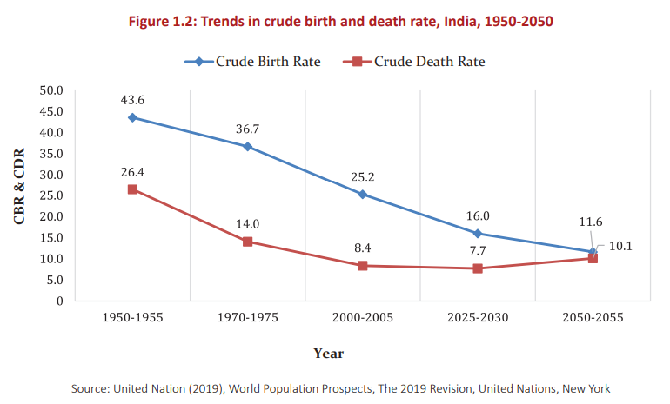

Figure 2‑1Trends in crude birth and death rate, India, 1950-2050

India's population distribution trends reveal a decline in the child population to 18.5% by 2050 from 37.5% in 1950. The working-age group (15-59 years) is expected to increase from 58.4% in 2000 to 62% by 2050. The median age will rise from 21.3 in 1950 to 38.1 in 2050, reflecting demographic transition. Additionally, the crude birth rate is projected to decrease from 20.4 in 2011 to 11.8 by 2050, while the crude death rate is expected to increase from 6.3 in 2017 to 7.3 in 2020.

While India is being propelled to a position of international eminence, it faces three main domains of health challenges.

* First, India needs to deal effectively with the unfinished agenda of communicable diseases, maternal and child health, and the strengthening of health systems.
* Second, it needs to deal with emerging challenges such as the premature burden of non-communicable diseases (NCDs).
* Third, India needs to deal with globalisation-related issues while also contributing to the management and shaping of the global policy environment.

However, out of pocket expenditures at the point of health service account for more than 70% of health expenditure, leading to health vulnerability in the older population. India is currently developing policies and establishing health care and social security programmes to support a rapidly ageing population. With India having a decentralised policy system, many of these programmes are to be implemented at the state level.

## Demography of ageing in India

India experiences unprecedented demographic shifts, with rising longevity and declining fertility creating a 'demographic dividend' but also increasing the elderly population, especially those aged 60 and above. The 'oldest old' (80 years and above) group has doubled in the past 65 years, contributing to a rapidly growing old-age dependency ratio. The feminization of the elderly poses unique challenges due to a widening life expectancy gender gap. The diverse needs of the elderly, from financial security to social participation, require nuanced policy responses for different age cohorts.

The elderly population is not a homogenous group, especially in a diverse society like India. The concerns of the young-old and oldest-old vary considerably in terms of financial security, functional incompetency, loneliness, and social and work participation. This pronounced diversity calls for a comprehensive understanding of various age cohorts within the elderly population so that appropriate measures and policies are formed well in time.

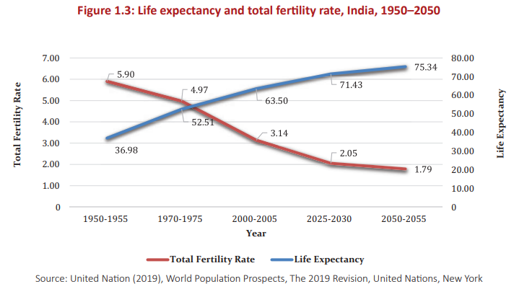

Figure 2‑2 Life expectancy and Fertility rate, India, 1950-2050

## Challenges and Impacts of an Ageing Workforce

By the year 2050, it is projected that the elderly population in India, comprising individuals aged 60 and above, will witness a significant surge, reaching approximately 340 million people.

#### Challenges Faced by the Elderly in India:

1. **Healthcare:** India lacks the necessary infrastructure and expertise to support the health and welfare of the elderly. Healthcare costs, lack of financial support, and seclusion are some of the major concerns for most Indian senior citizens. Additionally, the prevalence of chronic diseases and multimorbidity among the elderly population further exacerbates their healthcare needs.
2. **Work Participation and Productivity:** The labour force participation among the elderly population in India is significantly influenced by factors such as education, socioeconomic condition, gender, place of residence, and health status. Many elderly individuals continue to work in the informal sector, which is associated with unfavourable health outcomes, high rates of morbidity, and disability.
3. **Social and Economic Vulnerabilities:** The elderly population in India faces various vulnerabilities based on education, socioeconomic status, gender, and place of residence. These vulnerabilities can lead to disparities in access to healthcare, social support, and financial security, further impacting their overall well-being and work participation.
4. **Mental Health:** Mental health issues such as depression, anxiety, and cognitive decline are prevalent among the elderly population in India. These mental health challenges can negatively impact their work participation, productivity, and overall quality of life.

#### Impact on Productivity and Work:

1. **Health Status:** Health is the main determinant of working into old age in India. Chronic diseases and poor health conditions can lead to productivity loss among the middle-aged and elderly population. Ensuring healthy aging is crucial for maintaining work participation and productivity among the elderly in India.
2. **Informal Sector Employment:** A significant proportion of the elderly population in India works in the informal sector, which is associated with unfavourable health outcomes and limited social security benefits. This can lead to reduced productivity and increased vulnerability among the elderly workforces.
3. **Social Support and Living Arrangements:** The satisfaction and well-being of the elderly population are influenced by their living arrangements and social support systems [10]. Dissatisfaction with living arrangements can negatively impact their mental and physical health outcomes, further affecting their work participation and productivity.

The growing elderly population in India presents significant challenges related to work participation, productivity, and mental and physical health outcomes. Addressing these challenges requires a comprehensive approach that includes improving healthcare infrastructure, promoting healthy aging, ensuring financial security, and enhancing social support systems for the elderly population. To enhance the well-being and quality of life for the older population in India, policymakers have the opportunity to identify and tackle the factors that influence healthy aging. By doing so, they can actively promote and ensure the overall well-being of older individuals.

***Chapter 3***

# Literature Review

*This chapter gives a quick summary of the many research projects completed. This issue requires a comprehensive approach that addresses healthcare needs, gender inequality, economic implications, leadership capacity, and workforce diversity. Policies and initiatives targeting enhancement of the well-being and quality of life for older individuals, promoting gender equality, and advocating for retirement savings are crucial and of utmost importance.*

## Elderly age group studies conducted in India

Several studies conducted in India have explored the relationship between health issues, socioeconomic factors, and workforce participation among the elderly population.

1. A study using data from the Longitudinal Aging Study in India (LASI) found that alterations in social interactions can induce stress and precipitate cognitive decline in old age, affecting workforce participation.
2. Another study using LASI data found that health is the main determinant of working into old age, making healthy aging a priority for the future of the country.
3. A study using data from the 75th round of the NSSO survey found that the prevalence of self- reported chronic disease was 21 per 100 elderly Indian persons, with hypertension and diabetes being the most common diseases. These chronic illnesses can impair elderly people's capacity to work.
4. A cross-sectional study conducted in rural Bengaluru discovered the prevalence of frailty among elderly individuals was associated with factors such as age, gender, education, occupation, and the presence of chronic diseases. These factors can influence the workforce participation of older adults in India.
5. A study using data from the Building a Knowledge Base on Population Aging in India (BKPAI) survey found that socioeconomic status, social capital, and functional independence were associated with subjective well-being among older Indian adults. These factors can impact the ability of older adults to participate in the workforce.
6. A cross-sectional study conducted in rural Thanjavur district of South India found that the prevalence of physical frailty among community-dwelling older adults was 30.65%. The study also identified factors associated with frailty, including age, gender, education, occupation, and the presence of chronic diseases.
7. A study using data from the first wave of the Longitudinal Ageing Study in India analysed labour force participation among adults, the study examined the work attributes, earnings, and correlated social security advantages of individuals in the older age group. The study found that health status, especially in rural India, was the dominant predictor of labour force participation.
8. A study conducted in central Rajasthan found that the prevalence of frailty among elderly individuals was associated with variables like age, sex, and level of education, occupation, and the presence of chronic diseases.
9. A study using data from the 75th round of the NSSO survey examined the prevalence and determinants of chronic diseases among the population aged 60+ in India. The study discovered that city dwellers had a higher susceptibility to chronic ailments (OR, 1.15; 95% CI, 1.09-1.21) than countryside inhabitants.

### Derivative findings of studies

Here are some key findings:

1. Life satisfaction is related to socio-economic, physical, communal, and psychological wellness aspects among older persons in India. The Longitudinal Ageing Study in India (LASI-1) conducted during 2017-18 showed that despite relatively poor physical and mental health conditions, older Indian adults reported life satisfaction [10].
2. An investigation on the impact of informal sector employment on the health outcomes of aged workers in India revealed that Individuals involved in informal employment faced higher rates of unfavourable health consequences, such as elevated levels of morbidity and disability [21][32][41].
3. Work stress among older adults in the labour market in India is significantly associated with socio-economic and health risks like income, gender, education, morbidity, disability, and socio-psychological barriers [5].
4. The occurrence of multiple chronic conditions and depressive symptoms in the elderly population of India are found to have a mediating role in functional and behavioral health [23].
5. A study on the impact of employment involvement on the well-being of individuals in terms of both mental and physical health outcomes among older adults in India found that work participation was associated with better self-rated health status, lower prevalence of insomnia symptoms, lower prevalence of depression, and better cognitive functioning.
6. The influence of changes in work status and engagement in social activities on cognitive performance in the elderly population of India showed that changes in work and social participation can affect cognitive performance.
7. A research conducted on the association between chronic illnesses and the decline in productivity in middle-aged and older population people in India discovered that chronic disease-related productivity loss is common in this population.
8. In summary, recent research highlights the importance of work participation and its association with mental and physical health outcomes among the elderly in India. Factors such as life satisfaction, informal sector employment, work stress, multimorbidity, depression, and chronic diseases play significant roles in shaping the health and well-being of older adults in the country.

### Challenges in Conducting Research

Exploring health concerns and analysing workforce participation among the elderly population in India presents several challenges. Here are ten key challenges faced by researchers in this area:

1. **Heterogeneity of the elderly population:** Older adults are a diverse group with varying health conditions, socioeconomic backgrounds, and cultural factors, making it difficult to generalize findings across the entire population [12].
2. **Recruitment and retention:** Older adults may be less likely to participate in research studies due to health issues, mobility limitations, or lack of interest. Retaining participants in longitudinal studies can also be challenging due to attrition from health decline or death [29].
3. **Measurement and data collection:** Accurate measurement of health outcomes and workforce participation among older adults can be challenging due to the complexity of health conditions, the need for multidimensional assessment, and potential recall bias [30].
4. **Ethical considerations:** Research involving older adults may raise ethical concerns, such as obtaining informed consent from participants with cognitive impairments or ensuring the privacy and confidentiality of sensitive health information [44].
5. **Cultural factors:** Cultural elements, including social class and caste divisions, may have an impact on the health and overall welfare of elderly individuals in India. It is therefore crucial to incorporate these factors in research planning and examination [25].
6. **Access to healthcare:** Restricted availability of healthcare facilities and resources in remote regions can affect the health outcomes of older adults and their ability to participate in research studies [26].
7. **Longitudinal studies:** Long-term investigations are crucial in comprehending the enduring consequences of health ailments and engagement in work among the elderly cohort. However, these studies can be resource-intensive and time-consuming [27].
8. **Representativeness:** Ensuring that research samples are representative of the target population can be challenging, as older adults who participate in research studies may differ from those who do not in terms of health status, socioeconomic background, or other factors [18].
9. **Interdisciplinary collaboration:** Research on health issues and workforce participation among older adults requires collaboration among researchers from various disciplines, such as gerontology, public health, and economics. This can be challenging due to differences in research methodologies and priorities [39].
10. **Policy implications**: To bolster the health and workforce involvement of elderly individuals in India, it is necessary to convert research discoveries into impactful policies and interventions collaboration between researchers, policymakers, and practitioners, as well as an understanding of the complex social, economic, and political context [10].

## Navigating the Challenges of an Aging Workforce

Navigating the Challenges of an Aging Workforce in India is a complex issue that requires a multidimensional approach which can be seen as evident when looking at the following key findings:

* The growing senior population poses various issues, including increasing demand for healthcare services, an increased risk of chronic illnesses, and lower labour-force participation (Debnath et al., 2023; Gustafsson et al., 2022). It also emphasises the need of policies and Initiatives aimed at improving the well-being and enhancing the quality of life for the senior population of India (Debnath et al., 2023).
* One of the challenges of managing an aging workforce in India is the gender inequality and limited career advancement opportunities for women (Datta & Agarwal, 2017). Research has shown that Females make up a notable portion of the healthcare industry's workforce on a global scale, However, they are frequently concentrated in less prominent positions within the healthcare sector (Karan et al., 2021). This gender inequality in the workforce is a serious concern and needs to be addressed to ensure equal opportunities for women in the workplace (Datta & Agarwal, 2017).
* Another issue is The impact of continued employment during advanced ages on health results. A big proportion of India's elderly population works after retirement age, and the sort of employment they do can have serious consequences for their health. (Chowdhury et al., 2023; Chowdhury et al., 2022). Studies have shown that the type of work, whether formal or informal sector employment, plays a significant role in determining health outcomes among older workers (Chowdhury et al., 2023; Chowdhury et al., 2022). Factors such as socio-economic status, demographic characteristics, lifestyle behaviours, and work characteristics also influence health outcomes (Chowdhury et al., 2023).
* India's ageing workforce also creates economic issues, Factors such as rising expenditure on pensions and healthcare, the necessity for modifications in social security systems, and a shrinking workforce. (Singh et al., 2013; Venkatesan & Venkataraman, 2019). The ageing population need forward-thinking policies that encourage investing for a better living after retirement (Venkatesan & Venkataraman, 2019). Furthermore, the banking industry in India is experiencing labour issues as a result of shifting demographics and technology advancements (Roy & Vishwanathan, 2018). These issues include regulatory concerns, technological advancements, severe competition, and operational risk. (Roy & Vishwanathan, 2018).
* Furthermore, the leadership skills gap in the healthcare system is a concern for achieving ambitious health reforms in India (Gulati et al., 2022). The absence of structured and forward- looking leadership training for the healthcare workforce impedes the advancement of health reforms. (Gulati et al., 2022). Strengthening leadership capacity is crucial for effective management and implementation of healthcare policies and initiatives.
* To address the challenges of an aging workforce in India, it is important to develop evidence- based public health curricula and invest in the health workforce (Joshi et al., 2022). Understanding the needs, skills, and expertise required in the public health and allied fields is essential for effective workforce planning and development (Joshi et al., 2022). Additionally, managing diversity in the workforce is crucial for organizational efficiency and performance (Inegbedion et al., 2020). Strategically managing workforce diversity enhances organizational performance and contributes to inclusive growth (Inegbedion et al., 2020).

## Impact on Productivity and Well-being of Elderly Workers in India

The field of Impact on Productivity and Well-being of Elderly Workers in India has few research papers that can provide valuable insights into this topic:

1. In Bangalore, India, A neuroepidemiology study was carried out on a population basis, aiming to assess the prevalence and distribution of neurological diseases. (Gourie-Devi et al., 2004). This research gives data on the prevalence of neurological illnesses among India's senior population.
2. Discuss the significance of melatonin in energy metabolism, epigenetics, autophagy, and circadian rhythm pathways in ageing and neurodegeneration (Jenwitheesuk et al., 2014). This research also delves into the physiological changes that accompany ageing and their influence on well-being.
3. Explore gender disparities in the connections between informal caregiving and well-being within low and middle-income countries, including India (Bhan et al., 2020). This study focuses light on the difficulties that elderly carers confront and its influence on their well-being.
4. Examine the relationships between older living arrangements, job status, illness, and treatment- seeking behaviour in South Indian states (Paul & Verma, 2016). This study sheds light on the connection between living circumstances and well-being among senior employees.
5. Conducted a cross-sectional research to investigate the prevalence of depression and risk variables among older persons in a North Indian state (Debnath et al., 2023). This study highlights the mental health challenges faced by the elderly population and their impact on well-being.
6. Akpinar et al. Investigate the correlation between mental well-being and quality of life among elderly individuals employed in agricultural occupations. (AKPINAR et al., 2023). This research can offer valuable insights into the elements contributing to the well-being of senior workers within distinct professional environments.
7. Review the epidemiology of COVID-19, including its impact on the health and economy of India (Chowdhury & Oommen, 2020). This research can offer valuable insights into the obstacles encountered by older adults amid the COVID-19 pandemic and its repercussions on their overall well-being.Describe COVID-19 prevalence and severity patterns in vaccinated persons, especially the elderly (Kaur et al., 2021). This research might provide light on the efficacy of COVID-19 vaccinations in safeguarding the elderly and their well-being.
8. Investigates the link between labour demographics, such as age structure, and aggregate productivity Feyrer, 2007. This study discusses the influence of an ageing workforce on productivity, which is important for understanding the issues that senior workers confront in retaining productivity.
9. This document examines the influence of the aging workforce on productivity levels in Europe Aiyar & Ebeke (2016). This paper provides insights into the economic implications of an aging workforce and its impact on productivity.

These research papers encompass various subjects concerning the difficulties experienced by the aging workforce in India, including neurological disorders, caregiving, mental health, COVID-19, and productivity. These papers have the potential to offer a thorough comprehension of the effects of aging on the well-being and productivity of older employees in India.

## Research Gaps

These are certain research gaps in this area which highlight the need for further studies that delve into the specific factors influencing The efficiency and welfare of older workers in India, including the impact of living arrangements, socio-economic and demographic factors, gender disparities, and the prevalence of neurological disorders. Addressing these gaps can help to establish focused Initiatives and strategies for enhancing the welfare and productivity of elderly workers in India.

1. Limited understanding of the impact of living arrangements on The employment situation, prevalence of illness, and healthcare-seeking behavior among the elderly population in India Paul & Verma (2016).
2. There is a dearth of extensive analysis regarding the factors that influence labor force participation among the elderly population in India (Reddy, 2016).
3. Insufficient research on The precise nature of employment, industries, and occupations in which older individuals in India are engaged (Roy & Barua, 2023).
4. Limited knowledge about the relationship between The welfare of older adults in relation to different socio-economic and demographic factors. (Das et al., 2018).
5. Inadequate exploration of the linkages between productivity and well-being among elderly workers in India (Roy & Barua, 2023).
6. Lack of research on the specific challenges and opportunities faced by elderly workers in different sectors, such as healthcare, construction, and engineering (Al-Salem et al., 2017).
7. Limited understanding of the impact of family-related variables on The disparity in research productivity between female academics. (Aiston & Jung, 2015).
8. Limited exploration into the occurrence and distribution of neurological disorders among the elderly population in India. (Gourie-Devi et al., 2004).
9. Lack of research on The specific measures and policies required to enhance the welfare and productivity of elderly workers in India. (Debnath et al., 2023).
10. Limited exploration of the relationship between subjective financial well-being and other dimensions of well-being among the elderly in India (Nanda & Banerjee, 2021)

***Chapter 4***

# Proposed Work

*This chapter outlines the many methods and approaches employed.*

## Tools and Techniques Used

Details: Python serves as the foundation for the program we developed, utilizing numerous Python libraries to enhance its functionality.

### Tools

The libraries used include:

1. **Python**: Primary language for implementing the entire pipeline, leveraging popular libraries for data visualization and data analytics.
2. **Pandas**: A library designed for working with datasets, offering functions for analysing, cleaning, exploring, and manipulating data.
3. **NumPy**: A library utilized for working with arrays and offering functions for linear algebraic operations, Fourier analysis, and matrix operations.
4. **Git and Github** Version control and collaboration on the project codebase.
5. **Matplotlib**: A versatile library in Python that enables the creation of static, animated, and interactive visualizations with thorough functionalities., enabling easy creation of Generating plots and interactive figures of superior publication quality that allow zooming, panning, and updating functionalities.
6. **Scikit-learn (sklearn)**: A Python-based library that offers a cohesive interface for machine learning and statistical modeling tasks, encompassing efficient tools for classification, regression, clustering, and dimensionality reduction.
7. **Seaborn**: A Python library that leverages matplotlib to generate statistical graphics and seamlessly integrates with Panda's data structures, aiding in data exploration, and understanding.
8. **Jupyter Notebooks:** Google colab platform was Utilized for interactive development, experimentation, and documentation.
9. **Gensim:** It is a Python library for natural language processing and topic modeling. It's utilized for tasks like document similarity and topic extraction, offering efficient vector space modeling.

### Techniques

**Machine Learning**: Machine learning is a subfield of artificial intelligence that focuses on the development of algorithms and statistical models that enable computer systems to perform specific tasks effectively without explicit instructions, relying on patterns and inference instead. Machine learning algorithms construct a mathematical model based on sample data, known as "training data," to make predictions or decisions without explicit programming.

**Data Visualization**: In the context of machine learning, data visualization involves generating visual representations of data to extract insights and convey findings. It is a crucial aspect of the data analysis process, enabling practitioners to examine patterns and relationships within the data. Effective data visualization can facilitate the identification of trends, outliers, and anomalies in the data, as well as assist in model selection and evaluation.

## Overview of the process

**Process was divided into 3 primary tasks.**

1. **Work participation task**

In the work participation task, the focus was on identifying suitable job opportunities based on an individual's skills. A comprehensive dataset of job titles and corresponding skills was obtained, allowing for the clustering of similar job titles. This clustering facilitated the suggestion of potential jobs for individuals based on their skill sets, aligning their capabilities with available employment opportunities.

1. **Productivity task**

The productivity task involved assessing the performance of individuals in various job titles based on their age. Using data on job titles, employee ages, and performance metrics, an evaluation was conducted to determine if older individuals could be as productive as their younger counterparts. By clustering job titles, specific insights were gained, enabling the identification of roles where older employees demonstrated comparable or superior productivity levels.

1. **Mental health task**

In the mental health task, the focus shifted to predicting and understanding the mental well-being of older individuals. Relevant mental health data was gathered, allowing for a comprehensive analysis of factors influencing mental health in the elderly population. This task aimed to provide insights into the psychological aspects of aging, contributing to a holistic understanding of older individuals' mental health and well-being.

## Work Participation Task

### Detailed Process

1. **Data Importation:** Acquired the dataset through meticulous retrieval procedures, ensuring data integrity and completeness for subsequent analysis.
2. **Feature Selection:** Engaged in a thoughtful process of feature selection, considering domain expertise and project requirements to identify key variables crucial for achieving the proje­­ct's objectives.
3. **Data Cleaning**: Executed a thorough data cleaning process, addressing challenges such as redundant information, duplicate entries, and the presence of extraneous symbols. This phase focused on enhancing the dataset's quality and reliability.
4. **Numpy Array Creation:** Leveraged the power of numpy arrays to efficiently structure and manage the job titles and job skills data, laying a robust foundation for subsequent computations.
5. **Job Skills Vectorization:** Applied advanced vectorization techniques to the job skills data, transforming textual information into numerical representations. This process revealed intricate patterns and relationships among various skills.
6. **Dictionary Mapping:** Established a dictionary mapping each job title to its corresponding vectorized job skills. This mapping provided an organized structure, enabling swift and accurate retrieval of information during subsequent stages.
7. **Job Title Synthesis:** Innovatively synthesized job titles by amalgamating related job skills. This step aimed at creating consolidated and distinct titles, reflecting the core competencies required for each role.
8. **Job Titles Relation Analysis:** Conducted an exhaustive analysis to discern relationships between job titles. Special attention was given to instances where a subset of job skills for one title appeared within another, shedding light on potential overlaps and hierarchical structures.
9. **Vector Extraction:** Extracted vector representations corresponding to the synthesized job titles. These vectors served as essential numerical descriptors for each title, facilitating subsequent analyses.
10. **Vector Standardization:** Implemented vector standardization techniques to ensure uniform scales across all job title vectors. This step mitigated potential biases that could arise from variations in vector magnitudes.
11. **Dimensionality Reduction:** Utilized t-Distributed Stochastic Neighbour Embedding (t-SNE) to reduce the dimensionality of job title vectors. This transformation from 128 to 2 dimensions optimized visualization, enhancing interpretability.
12. **Cluster Analysis with K-Means:** Deployed the K-Means clustering algorithm to unveil underlying structures within the data. The exploration of the elbow method assisted in determining the optimal number of clusters, revealing four distinct groupings.
13. **Cluster Creation:** Formed cohesive clusters of job title vectors based on the optimal cluster number. This grouping facilitated the identification of patterns and similarities among job titles.
14. **Visualization:** Generated visually appealing representations of the clustered job title vectors. The visualizations provided an intuitive and insightful overview of the relationships and structures inherent in the data.

### K-means Clustering

K-Means Clustering is an unsupervised learning algorithm that is used to solve the clustering problems in machine learning or data science. In this topic, we will learn what is K-means clustering algorithm, how the algorithm works, along with the Python implementation of k-means clustering.

* It allows us to cluster the data into different groups and a convenient way to discover the categories of groups in the unlabeled dataset on its own without the need for any training.
* It is a centroid-based algorithm, where each cluster is associated with a centroid. The main aim of this algorithm is to minimize the sum of distances between the data point and their corresponding clusters
* The algorithm takes the unlabeled dataset as input, divides the dataset into k-number of clusters, and repeats the process until it does not find the best clusters. The value of k should be predetermined in this algorithm.

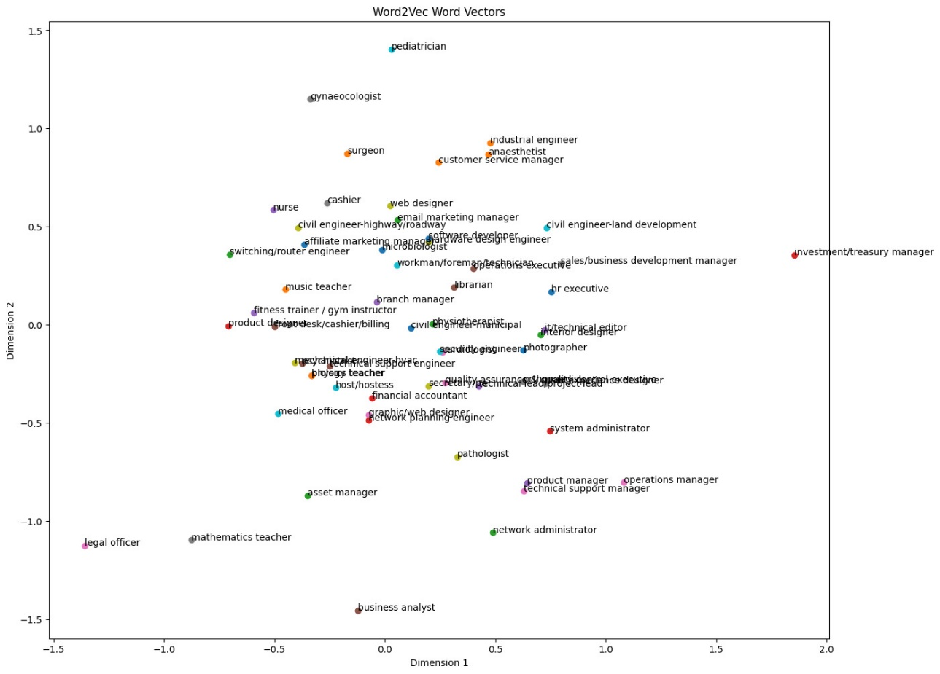

Figure 4‑1 Vector representation of all skills

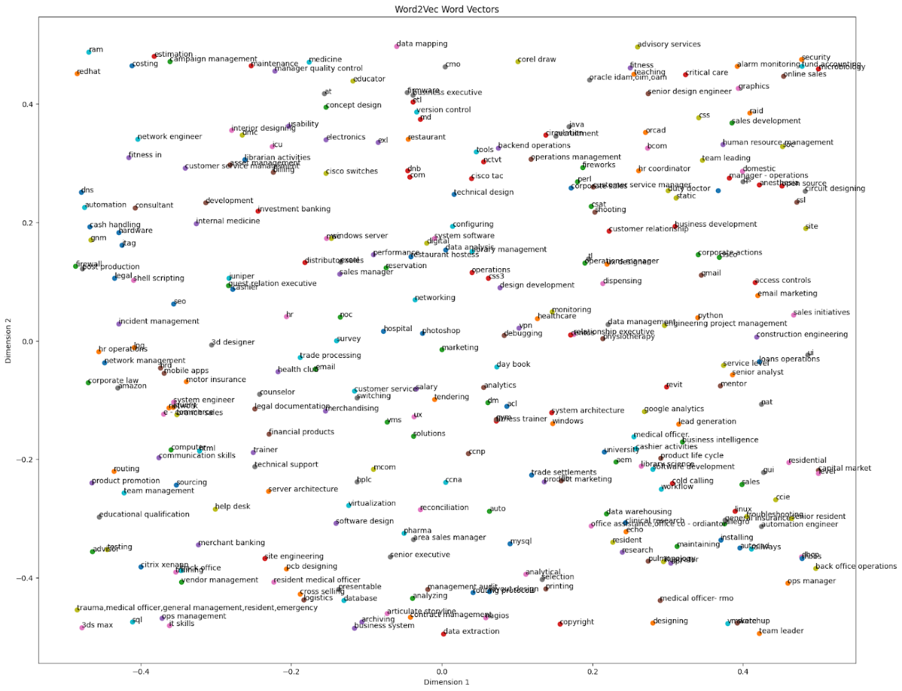

Figure 4‑2 Vector representation of all skills

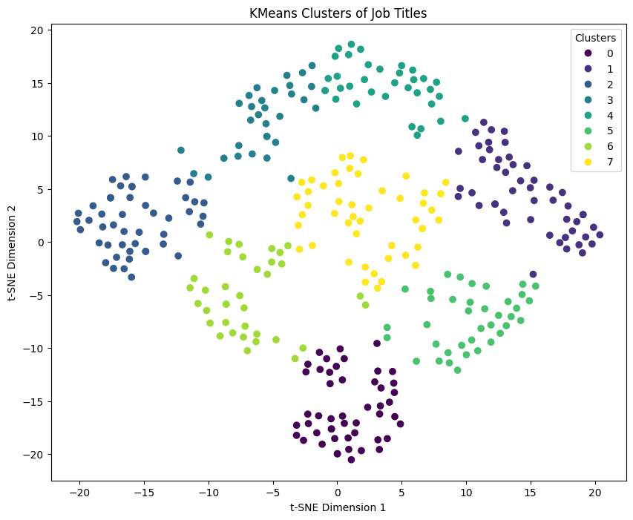

Figure 4‑3 Representation of all job clusters

The job titles were subjected to clustering based on their associated skills, employing the K-Means algorithm to discern patterns within the dataset. After a careful analysis, the optimal number of clusters was determined to be 8. This strategic clustering not only categorizes jobs but also groups them in a manner that reflects the similarities in the required skill sets.

To elaborate further, the K-Means algorithm segregates job titles into distinct clusters, each characterized by a set of shared skills. The underlying assumption is that jobs within the same cluster exhibit analogous skill requirements. Consequently, when seeking jobs with similar skill profiles, one can effectively consider other jobs within the same cluster as potential matches. This clustering approach facilitates a more nuanced understanding of job relationships, aiding both job seekers and employers in identifying roles that align closely with specific skill prerequisites.

The utilization of the K-Means algorithm in clustering job titles provides a systematic and data-driven method to organize roles based on skill similarities. This approach enhances the efficiency of job searches by enabling individuals and organizations to explore related roles within the same cluster, streamlining the process of identifying suitable job opportunities

## Productivity Task

**JavaScript Implementation for API and On-the-Fly Calculations**: Utilized JavaScript to implement the API layer, facilitating seamless communication between the front-end and back-end components. Additionally, incorporated on-the-fly calculations to dynamically process and update data in real-time, enhancing the responsiveness of the application.

**C++ for Data Transformation and Precalculations**: Employed C++ for handling data transformation tasks and precalculations. This allowed for efficient processing of large datasets and the execution of complex algorithms, optimizing performance in scenarios requiring heavy computational tasks.

**Ranking Clustering Algorithm Output by Productivity**: Designed and implemented a clustering algorithm to organize data. The output of the algorithm was ranked based on productivity, providing insights into the effectiveness of the clustering process in categorizing data according to specified criteria.

**Relative Increase in Appraisal as a Productivity Measure:** Utilized the relative increase in appraisal as a key productivity measure. This metric served as an indicator of performance improvement, allowing for a quantitative assessment of the impact of various factors on job productivity within the clustering model.

**Dynamically Calculated Job Suitability Based on Age**: Implemented dynamic calculations to assess the suitability of a job for an individual based on their age. This feature provided personalized recommendations by considering age as a determining factor in job compatibility within the model.



**User Interface for Model Interaction**: Developed a user-friendly interface to facilitate user interaction with the model. The interface allowed users to input parameters, visualize clustering results, and obtain personalized recommendations based on the model's calculations.

**Quantization of Generative AI Model (4-bit Quantization)**: Quantized a generative AI model to operate on personal laptops efficiently. The model was adapted using 4-bit quantization, resulting in a reduction in accuracy. However, this trade-off made development more accessible and cost-effective, enabling deployment on resource constrained devices.

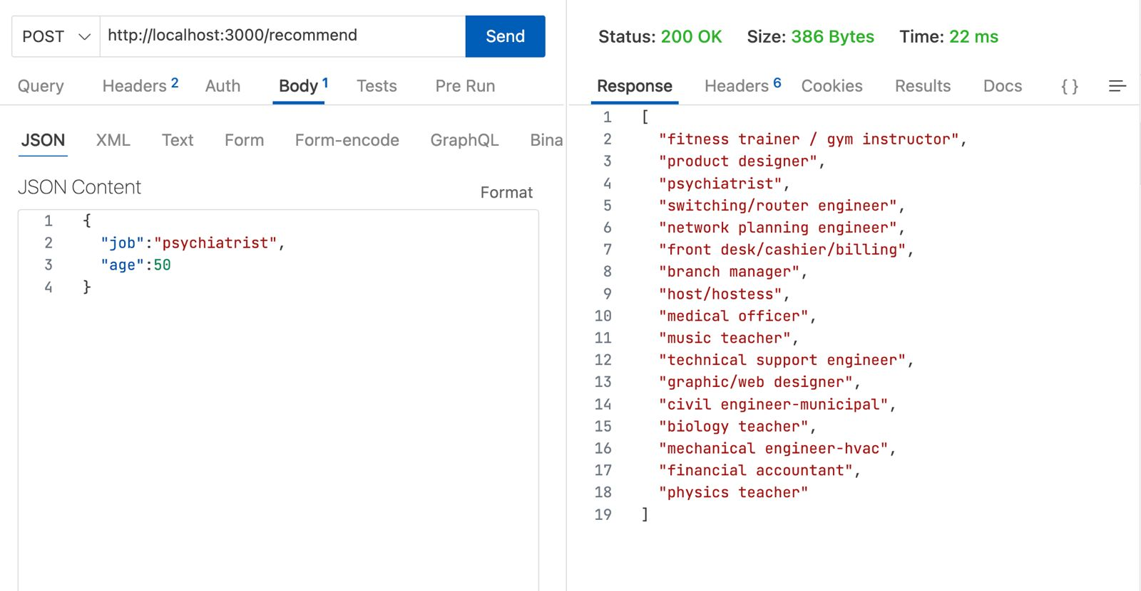

Figure 4‑4 Sample API call

Upon receiving the user's current job and age, our system initiates a process to optimize job recommendations. First, we identify the cluster associated with the user's current job, categorizing similar roles based on skills and characteristics. Subsequently, we retrieve all jobs within this cluster. To enhance user experience, we sort these jobs based on relative productivity at the given age, prioritizing roles where individuals of a similar age have demonstrated higher productivity. The sorted list is then presented to the user, offering tailored job suggestions aligned with their skills and age-related productivity trends. This approach aims to assist users in exploring potentially more suitable and productive career opportunities.

## Mental Health Task

Mental health issues can affect individuals of any age, and older adults are not exempt from experiencing mental health challenges, especially after retirement. Several factors contribute to mental health problems in the elderly during this life stage:

1. **Social isolation**: Retirement often leads to a significant change in daily routines and a reduction in social interactions. Older adults may lose the social connections that were a part of their work life, which can contribute to feelings of loneliness and isolation.

2. **Loss of identity and purpose**: Work often provides a sense of purpose and identity for individuals. After retirement, some people may struggle with a loss of purpose and may find it challenging to adjust to a life without the structure and goals associated with their careers.

3. **Financial concerns**: The transition to a fixed income in retirement can be stressful, especially if there are financial uncertainties or unexpected expenses. Financial worries can contribute to anxiety and depression in older adults.

4. **Physical health issues**: Aging is often accompanied by health challenges, and physical health issues can have a significant impact on mental well-being. Chronic pain, mobility issues, and other health concerns can contribute to feelings of frustration and sadness.

5. **Cognitive decline:** Aging is associated with a natural decline in cognitive function for some individuals. Conditions such as dementia or Alzheimer's disease can further exacerbate cognitive challenges, leading to emotional distress.

6. **Grief and loss**: Older adults may experience the loss of loved ones, friends, or spouses, and coping with grief can be particularly challenging. The accumulation of losses over time can contribute to mental health issues.

7. **Lack of mental health awareness**: Older adults may be less likely to seek help for mental health concerns due to stigma or a lack of awareness about available resources. This can lead to untreated mental health conditions.

**Addressing mental health issues in older adults after retirement involves a holistic approach:**

* Encouraging social engagement and maintaining relationships.
* Providing opportunities for purposeful activities, such as volunteering or pursuing hobbies.
* Offering financial planning support and resources.
* Promoting physical health through regular exercise and healthcare.
* Raising awareness about mental health and reducing stigma.
* Ensuring access to mental health services and support.

It's important for family members, caregivers, and healthcare professionals to be aware of the unique challenges faced by older adults after retirement and to provide the necessary support to promote mental well-being.

**­**

### Proposed Solution

*“Developing an Ensemble Classification Model for Predicting Mental Health: A Comprehensive Solution”*

This proposed solution delineates a comprehensive approach to constructing an ensemble classification model for predicting mental health outcomes. Integrating logistic regression and decision tree models, optimized through grid search for hyperparameters, aims to establish a robust and efficient predictive tool. Rigorous evaluation, validation, and iterative refinement will be pivotal in ensuring the model's effectiveness in real-world mental health scenarios**.**

Mental health prediction has emerged as a paramount area of research, underscored by the increasing acknowledgement of the pivotal role early identification and intervention play in improving outcomes. Our proposed solution represents a significant stride toward meeting this imperative by formulating an advanced ensemble classification model. This innovative approach amalgamates the distinctive strengths of logistic regression and decision tree models, strategically intertwining their capabilities. The synergy of these models, coupled with meticulous hyperparameter optimization through grid search, presents a multifaceted strategy aimed at elevating predictive accuracy and enhancing the overall interpretability of the resultant model. This endeavour is not only aligned with the pressing societal need for more effective mental health predictions but also reflects a commitment to leveraging state-of-the-art methodologies for comprehensive and impactful solutions.

**Benefits of the Proposed Solution:**

* **Increased Predictive Accuracy:** The ensemble approach harnesses the synergies between logistic regression and decision tree models, capturing a wide spectrum of data nuances. This collaborative approach leads to a heightened level of predictive accuracy, ensuring a more robust and reliable mechanism for mental health outcome predictions.
* **Optimized Hyperparameters:** The proposed solution employs a systematic exploration of hyperparameter combinations through grid search, a strategic process that fine-tunes model settings. This meticulous optimization not only enhances precision but also ensures that the models are finely calibrated to the intricacies of the given dataset, maximizing their overall performance.
* **Mitigation of Overfitting:** To address the common challenge of overfitting, the solution incorporates thoughtful measures such as regularization in logistic regression and pruning in decision trees. The ensemble techniques employed contribute to the generalization of the model to new data, ensuring that predictions are not skewed by noise or outliers.
* **Interpretability and Explainability:** The combination of logistic regression and decision trees brings a dual-model approach that balances interpretability and complexity. Logistic regression provides transparency in the decision-making process, while decision trees can be visualized, offering a nuanced understanding of the factors influencing mental health predictions. This ensures that the model's outcomes are not just accurate but also comprehensible to stakeholders.
* **Flexibility in Model Complexity:** The ensemble model allows for a dynamic balance between model complexity and interpretability. While decision trees excel at capturing intricate relationships in the data, logistic regression serves as a baseline with simpler and more interpretable insights. This adaptability makes the solution well-suited for addressing different levels of complexity within diverse mental health datasets.
* **Robustness and Resilience:** Leveraging ensemble techniques enhances the robustness of the model. By compensating for individual weaknesses in one model with the strengths of another, the ensemble becomes more resilient to noise or outliers in the data. This contributes to a stable and reliable prediction mechanism, crucial in the context of mental health outcomes.
* **Cross-Validation for Model Evaluation:** The inclusion of cross-validation in the evaluation process ensures a thorough assessment of the model's performance across diverse subsets of the data. This approach provides a realistic estimate of how well the model is likely to perform on unseen data, promoting better generalization and reliability in real-world scenarios.
* **Applicability to Real-World Scenarios:** The solution prioritizes real-world effectiveness, emphasizing that the developed model is not only accurate but also practical for application in dynamic mental health scenarios. Regular evaluation and refinement protocols contribute to the model's reliability and relevance in addressing the evolving nature of mental health challenges.
* **Enhanced Decision Support:** The ensemble model's amalgamation of logistic regression and decision tree predictions results in a comprehensive decision support system. This sophisticated tool assists healthcare professionals in gaining a deeper understanding of the nuanced factors contributing to mental health outcomes, enabling more informed and targeted interventions. The model becomes an invaluable asset in enhancing the quality of decision-making within healthcare contexts.

### Methodology

#### Importing Libraries and Pulling Dataset

Importing necessary libraries, such as pandas, numpy, scikit-learn, and matplotlib and loaded the dataset into a pandas Data Frame using appropriate functions.

#### EDA and Data Preparation

* Cleaning the Data
* Identify and handle missing values, outliers, and any data quality issues.
* Perform necessary imputations or removal of problematic data points.
* EDA
* Conduct exploratory data analysis (EDA) to gain insights into the dataset.
* Visualize key statistics, distributions, and relationships between variables.
* Identify patterns and potential correlations.
* Respondent Demography with Respect to Target
* Explore demographic characteristics of respondents with respect to the target variable (mental health status).
* Visualize demographic distributions and their impact on mental health.
* Working Conditions with Respect to Target
* Analyze working conditions in relation to mental health.
* Identify potential stressors or factors influencing mental health outcomes.
* Workplace Benefits, Facilities, and Confidentiality
* Investigate the impact of workplace benefits, facilities, and confidentiality on mental health.
* Identify any patterns or trends that may influence mental health status.
* Data Pre-processing
* Pre-process the data for model building.
* Handle categorical variables, scale numerical features, and encode any necessary transformations.

#### Logistic Regression Model

* Implement a logistic regression model on the pre-processed data.
* Set up a confusion matrix to evaluate model performance.
* Check the model's performance on both the training and test sets.

**Setting Up a Confusion Matrix**

Define and calculate metrics such as accuracy, precision, recall, and F1-score using the confusion matrix.

A confusion matrix is a table used in classification to assess the performance of a machine learning model. It provides a comprehensive view of the predictions made by a model by comparing them to the actual labels. The four main components of a confusion matrix are True Positives (TP), True Negatives (TN), False Positives (FP), and False Negatives (FN). These components are used to calculate various metrics that evaluate the model's performance.

**Here's a breakdown of the components of a confusion matrix:**

* True Positives (TP):
* Instances that are actually positive and are correctly predicted as positive by the model.
* True Negatives (TN):
  + Instances that are actually negative and are correctly predicted as negative by the model.
* False Positives (FP):
  + Instances that are actually negative but are incorrectly predicted as positive by the model. Also known as Type I errors.
* False Negatives (FN):
  + Instances that are actually positive but are incorrectly predicted as negative by the model. Also known as Type II errors.

We can calculate accuracy, precision, recall and F1 score of model to test performance of our model.



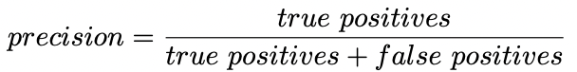

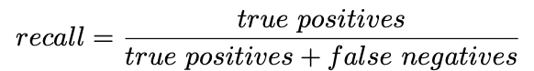

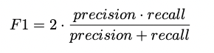

**Check Model Performance on Training and Test Set**

* Evaluate the logistic regression model on the training set to ensure it is learning from the data.
* Assess its performance on the test set to gauge generalization.
* For this ROC-AUC curve can be used-

ROC-AUC, or Receiver Operating Characteristic - Area Under the Curve, is a metric used to evaluate the performance of a binary classification model. It is particularly useful when dealing with imbalanced datasets where one class is more prevalent than the other.

Receiver Operating Characteristic (ROC) Curve:

* + The ROC curve is a graphical representation of a binary classification model's performance across different threshold settings. It plots the True Positive Rate (Sensitivity or Recall) against the False Positive Rate for various threshold values.
  + The curve helps to visualize how well the model distinguishes between positive and negative instances across different decision boundaries.

Area Under the Curve (AUC):

* + AUC represents the area under the ROC curve. It quantifies the model's ability to discriminate between positive and negative instances.
  + AUC ranges from 0 to 1, where a higher AUC indicates better model performance. A model with an AUC of 0.5 is essentially making random predictions, while an AUC of 1.0 represents perfect discrimination.

**Defining the Matrix**

Interpret the confusion matrix results and discuss the trade-offs between false positives and false negatives.

**Finding the Balanced Threshold Using the Precision-Recall Curve**

* Explore different threshold values for balancing precision and recall using the precision-recall curve.
* Choose an optimal threshold that aligns with project goals.

#### Tuned Logistic Regression

Hyperparameter tuning is a critical step in the model development process to ensure that the chosen algorithm is configured optimally for a specific task, leading to improved performance, generalization, and robustness. It's an integral part of achieving the best possible model for a given problem.

Here to do the tuning we follow the given steps using GRID SEARCH METHOD

steps

**Define the Model:** Choose the machine learning algorithm you want to tune, and define its architecture or structure.

**Define the Hyperparameter Grid:** Specify the hyperparameters you want to tune and their possible values. This creates a grid of hyperparameter combinations to be tested.

**Set up Cross-Validation:** Choose a cross-validation strategy (e.g., k-fold cross-validation) to evaluate model performance on different subsets of the training data.

**Perform Grid Search:** Train the model using each combination of hyperparameter values defined in the grid. Evaluate the model's performance using cross-validation and a specified evaluation metric.

**Select the Best Model:** Identify the combination of hyperparameter values that result in the best performance according to the chosen evaluation metric.

**Train the Final Model:** Train the model using the entire training dataset and the selected optimal hyperparameter values.

**Evaluate on Test Set:** Assess the final model's performance on a separate test set to ensure it generalizes well to new, unseen data.

Fine-tune hyperparameters of the logistic regression model using grid search or other optimization techniques.

Re-evaluate model performance after hyperparameter tuning.

#### Decision Tree Model

* Implement a decision tree model on the pre-processed data.
* Assess the model's performance on training and test sets.

#### An Overfitted Model! Let's Try to Fix This

* Identify signs of overfitting in the decision tree model.
* Discuss strategies for addressing overfitting.

#### Tuned Decision Tree Model

* Fine-tune hyperparameters of the decision tree model using techniques such as pruning or grid search.
* Evaluate the model's performance after hyperparameter tuning.

#### Reducing the Overfitting Problem

* Discuss how the tuned decision tree model addresses overfitting.
* Compare the performance before and after tuning.

#### Testing and Conclusion

* Compare the performance of the logistic regression and decision tree models.
* Draw conclusions about the effectiveness of each model.
* Discuss the implications of the findings for predicting mental health based on the dataset.

**Comparing the Models**

* Provide a comprehensive comparison of the logistic regression and decision tree models.
* Consider metrics such as accuracy, precision, recall, and F1-score.

### Experimental Setup

A comprehensive study leveraging data from Open Sourcing Mental Health (OSMI), a non-profit organization committed to fostering mental wellness within the tech and open source communities, has been conducted. OSMI is dedicated to raising awareness, delivering education, and offering resources to support mental well-being in these sectors.

The study focused on the OSMI Mental Health in Tech Survey 2014, which garnered responses from over 1200 participants. The primary objective of this survey was to assess attitudes toward mental health within the tech workplace. Additionally, it sought to explore the prevalence of mental health disorders among individuals working in the tech industry. This valuable dataset provides insights into the nuanced landscape of mental wellness within the tech and open source communities, shedding light on the challenges and opportunities for fostering a supportive and healthy work environment.

### Visualization of Data

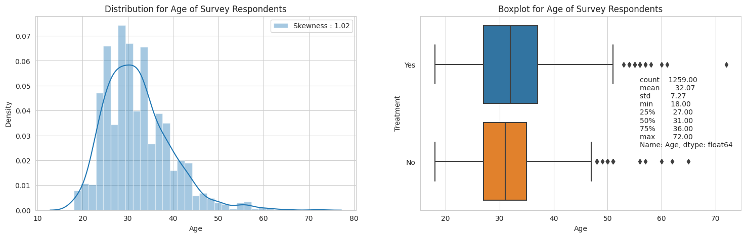

Figure 4‑5 Graphical Analysis of age respondents in data

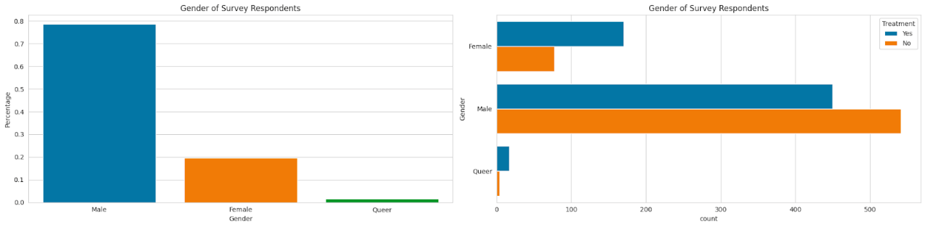

Figure 4‑6 Graphical Representation of gender of respondents in data

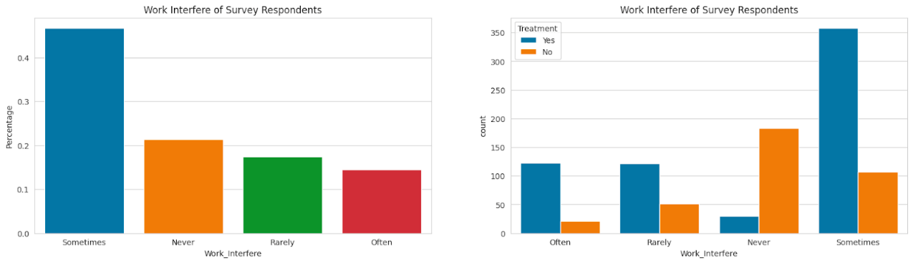

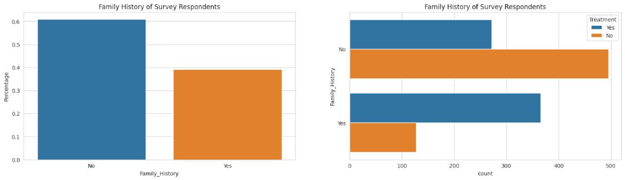

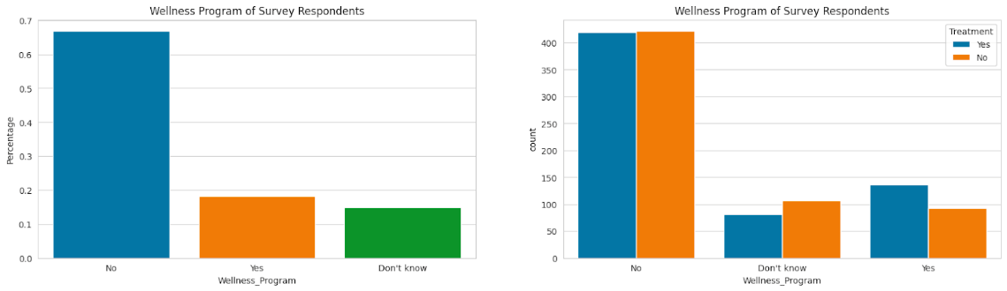

Figure 4‑7 Graphical Representation of major attributes of data based on questions asked in survey

### Logistic Regression Results

Logit Regression Results

==============================================================================

Dep. Variable: Treatment No. Observations: 881

Model: Logit Df Residuals: 836

Method: MLE Df Model: 44

Date: Tue, 05 Dec 2023 Pseudo R-squ.: 0.4755

Time: 07:00:01 Log-Likelihood: -320.29

converged: True LL-Null: -610.63

Covariance Type: nonrobust LLR p-value: 8.885e-95

=========================================================================================================

coef std err z P>|z| [0.025 0.975]

---------------------------------------------------------------------------------------------------------

const -4.2152 0.901 -4.678 0.000 -5.981 -2.449

Age 0.0232 0.015 1.591 0.112 -0.005 0.052

Gender_Male -0.7186 0.279 -2.579 0.010 -1.265 -0.172

Gender_Queer -0.2180 0.859 -0.254 0.800 -1.901 1.465

Self_Employed_Yes -0.2609 0.398 -0.655 0.512 -1.041 0.519

Family_History_Yes 0.9601 0.218 4.397 0.000 0.532 1.388

Work_Interfere_Often 4.3911 0.408 10.758 0.000 3.591 5.191

Work_Interfere_Rarely 3.1203 0.325 9.613 0.000 2.484 3.756

Work_Interfere_Sometimes 3.7490 0.291 12.887 0.000 3.179 4.319

Employee_Count_Company_100-500 0.3543 0.469 0.756 0.450 -0.565 1.273

Employee_Count_Company_26-100 0.4151 0.428 0.969 0.332 -0.424 1.255

Employee_Count_Company_500-1000 0.2749 0.624 0.441 0.659 -0.947 1.497

Employee_Count_Company_6-25 0.1318 0.397 0.332 0.740 -0.646 0.909

Employee_Count_Company_More than 1000 0.2106 0.462 0.456 0.649 -0.695 1.116

Remote_Work_Yes -0.0774 0.249 -0.311 0.756 -0.565 0.410

Tech_Company_Yes -0.3363 0.279 -1.204 0.228 -0.884 0.211

Benefits_No 0.1740 0.314 0.553 0.580 -0.442 0.790

Benefits_Yes 0.6238 0.321 1.943 0.052 -0.006 1.253

Care_Options_Not sure -0.0608 0.286 -0.212 0.832 -0.622 0.501

Care_Options_Yes 0.6890 0.283 2.437 0.015 0.135 1.243

Wellness_Program_No 0.1097 0.351 0.313 0.755 -0.578 0.798

Wellness_Program_Yes -0.0988 0.431 -0.229 0.819 -0.944 0.746

Seek_Help_No -0.3857 0.309 -1.247 0.212 -0.992 0.220

Seek_Help_Yes -0.7448 0.379 -1.966 0.049 -1.487 -0.002

Anonymity_No 0.1037 0.483 0.215 0.830 -0.844 1.051

Anonymity_Yes 0.5961 0.276 2.156 0.031 0.054 1.138

Medical_Leave_Somewhat difficult 0.6841 0.385 1.776 0.076 -0.071 1.439

Medical_Leave_Somewhat easy -0.1587 0.287 -0.553 0.580 -0.721 0.403

Medical_Leave_Very difficult 0.6205 0.430 1.444 0.149 -0.222 1.463

Medical_Leave_Very easy 0.1297 0.331 0.392 0.695 -0.518 0.778

Mental_Health_Consequence_No -0.0672 0.295 -0.227 0.820 -0.646 0.512

Mental_Health_Consequence_Yes -0.1050 0.306 -0.343 0.732 -0.705 0.495

Physical_Health_Consequence_No 0.0455 0.276 0.165 0.869 -0.495 0.586

Physical_Health_Consequence_Yes -0.1052 0.515 -0.204 0.838 -1.116 0.905

Coworkers_Reach_Some of them 0.6381 0.282 2.259 0.024 0.084 1.192

Coworkers_Reach_Yes 1.0379 0.425 2.442 0.015 0.205 1.871

Supervisor_Reach_Some of them -0.3543 0.293 -1.209 0.227 -0.929 0.220

Supervisor_Reach_Yes -0.5082 0.331 -1.534 0.125 -1.157 0.141

Mental_Health_Interview_No 0.4890 0.342 1.429 0.153 -0.181 1.159

Mental_Health_Interview_Yes 0.6999 0.703 0.996 0.319 -0.677 2.077

Physical_Health_Interview_No -0.0682 0.243 -0.281 0.779 -0.545 0.409

Physical_Health_Interview_Yes 0.3833 0.341 1.123 0.261 -0.285 1.052

Mental_VS_Physical_No -0.0661 0.277 -0.239 0.811 -0.609 0.477

Mental_VS_Physical_Yes 0.3307 0.297 1.115 0.265 -0.251 0.912

Observed_Consequence_Workplace_Yes -0.0687 0.325 -0.211 0.833 -0.706 0.569

**Confusion matrix of logistic regression model to test performance**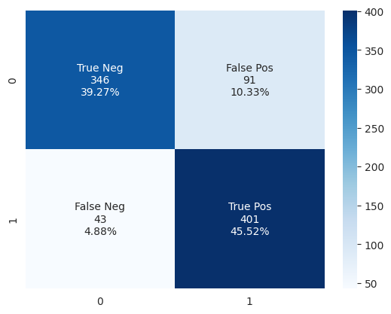

**Checking model performance on train set**

Figure 4‑8 Checking model performance on train set

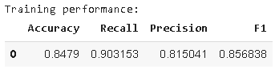

**Checking model performance on test set**

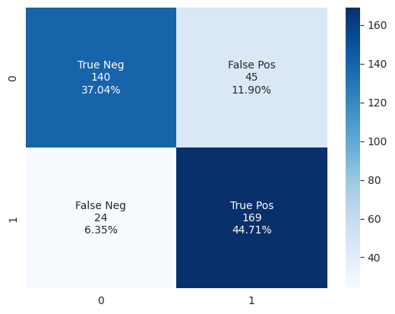

Figure 4‑9 Checking model performance on test set

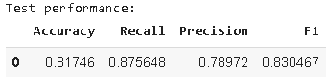

**Utilizing Receiver Operating Characteristic (ROC) Curve and Area Under the Curve (AUC) to determine skill of model**

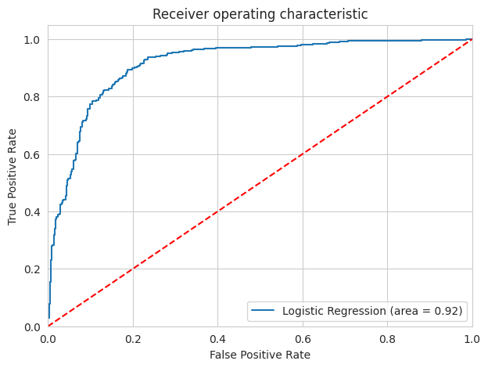

Figure 4‑10 skill of model curve

Compared to the unskilled model (red line) our skilled model (blue line) is very strong.  AUC is also high i.e. 0.92.

Our model is decently skilled!

Finding balanced threshold

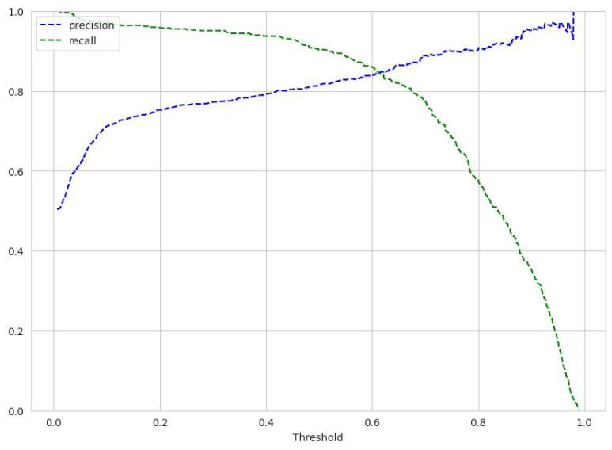

Figure 4‑11 Balanced threshold

Balanced threshold is somewhere around 0.63

### Tuned Logistic Regression

Testing performance on training set

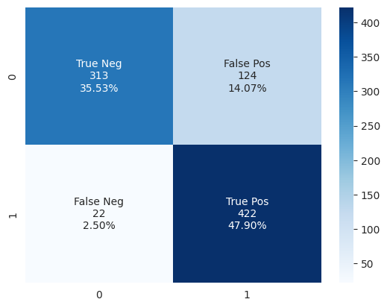

Figure 4‑12 Tuned Logistic Regression testing performance

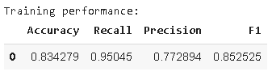

**Checking model performance on test set:**

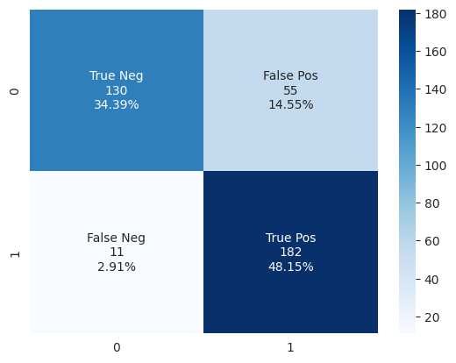

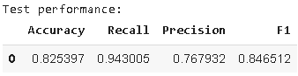

**Performance of decision tree model**

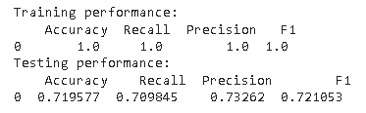

Figure 4‑13 Performance of decision tree model

We were able to solve the overfitting model but the results show poorer performance than our logistic regression. This model is not that good.

**Confusion matrix of tuned decision tree model**

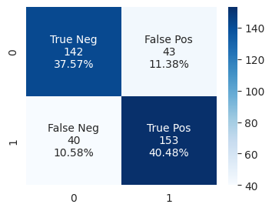

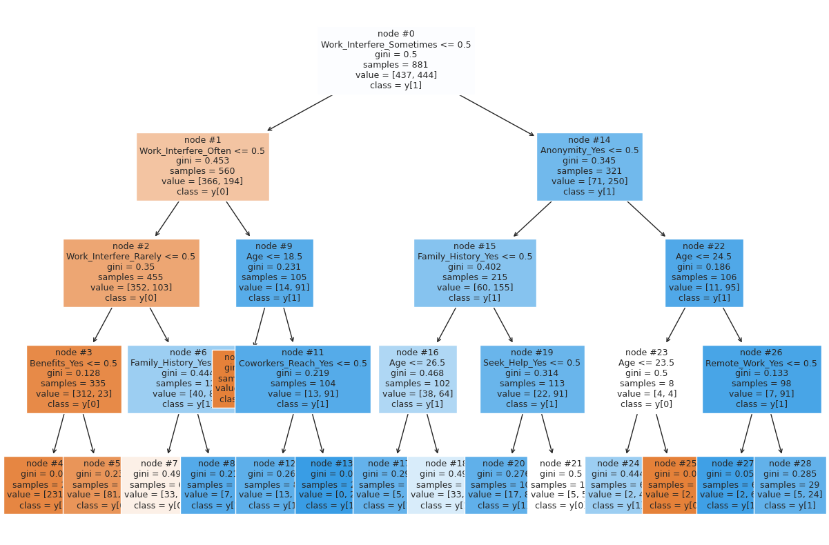

### Comparing Performance of models:

Table 1 Testing performance comparison

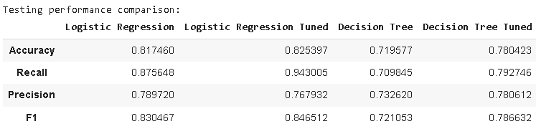

The logistic regression tuned model is most ideal: Has the highest accuracy, recall, and F1 among the four models generated.

### Conclusion

Several predictor variables have significant coefficients, indicating that they have a statistically significant effect on the outcome variable. For instance, family history, work interference, and care options are positively related to the likelihood of receiving treatment. Work interference variables are the highest positive values among the variables. This indicates that when mental health interferes with work, they are more likely to seek medical help. Having a family history of a mental health condition, awareness of the presence of benefits, and care options, and anonymity in the workplace make it more likely that the employee will seek medical help.

Interestingly, reaching out to coworkers may more likely prompt an employee to seek medical help; while reaching out to supervisors decreases the chance to seek medical help. Gender variables are negative, meaning males and queers are more likely to avoid getting medical help than females.

**We used four models in total**

* Logistic regression model
* Tuned Logistic regression model
* Decision Tree Model
* Tuned Decision Tree Model

The logistic regression tuned model is ideal: Has the highest accuracy, recall, and F1 among the four models generated. Ideally, we should reiterate that, for this subject we want as many employees to be identified as needing treatment so we want a high recall.

***Chapter 5***

# Results and Discussion

*In this chapter, the outcomes of our model are explained*

## Results

**Work Participation Task:**

The application of the K-Means algorithm in clustering job titles yielded valuable insights into skill-based patterns within the dataset. With eight determined clusters, the approach effectively categorized jobs and identified shared skill sets. This systematic organization enhances job searches, allowing users and organizations to explore related roles within the same cluster. The K-Means algorithm proves to be a robust and data-driven method, streamlining the identification of suitable job opportunities by considering skill similarities.

**Productivity Task:**

In the productivity task, the system optimized job recommendations based on the user's current job and age. By associating the user's job with a specific cluster, jobs with similar skill profiles were retrieved and sorted based on relative productivity at the given age. The approach aims to assist users in exploring more suitable and productive career opportunities aligned with their skills and age-related productivity trends. This tailored recommendation system offers a strategic and user-centric approach to career planning.

**Mental Health Task:**

The analysis of predictor variables in the mental health task revealed significant coefficients influencing the likelihood of seeking treatment. Variables such as family history, work interference, and care options demonstrated a positive relationship with seeking medical help. Notably, gender variables indicated that males and non-binary individuals were more likely to avoid seeking medical help than females. Four models were employed, with the logistic regression tuned model emerging as the most ideal, boasting the highest accuracy, recall, and F1 scores. This emphasizes the importance of tailored interventions, considering the diverse factors impacting employees' decisions to seek mental health treatment.

These results collectively underscore the effectiveness of data-driven approaches in workforce management. The systematic clustering of job titles enhances job searches, while personalized recommendations based on productivity trends and mental health considerations contribute to a more user-centric and supportive work environment. The findings offer valuable insights for both individuals and organizations seeking to optimize workforce engagement, career satisfaction, and overall well-being.

## Comparison with state-of-the-art

This effort adds to the limited research on the topic in India and is consistent with other studies that show a good relationship between employment engagement, productivity, and health outcomes among the senior population. The study points out the socio-economic and demographic determinants of elderly labour force participation in India. There are important insights into the patterns and determinants of elderly workforce participation in India and it sheds light on the prevalence of informal sector employment, low-skilled occupations, and the influence of socio-economic factors on labour force participation among the elderly, and in comparison to state-of-the-art studies, these Indian studies also contribute to the understanding of elderly workforce participation in a specific context, taking into account the unique socio-economic and demographic factors of India. They provide valuable evidence on the changes in labor force participation among the elderly over time and highlight the need for further research in this area.

***Chapter 6***

# Conclusion and Future work

*In this chapter, the future perspectives of this model are explained*

In conclusion, the integration of data-driven approaches, such as clustering job titles and optimizing job recommendations, has proven to be instrumental in enhancing workforce management. The K-Means algorithm's application in the work participation task streamlined job searches by categorizing roles based on shared skill sets, providing a nuanced understanding of job relationships for both job seekers and employers. The productivity task optimized job recommendations, aligning roles with users' skills and age-related productivity trends, fostering more suitable and productive career opportunities. The mental health task's analysis of predictor variables shed light on significant factors influencing employees' decisions to seek treatment, emphasizing the importance of tailored interventions and support systems.

For future work, the system can be further refined by incorporating real-time data and continuous learning mechanisms. This would enable the model to adapt to evolving skill requirements, productivity trends, and mental health dynamics in the workforce. Additionally, exploring advanced clustering algorithms and machine learning techniques could enhance the accuracy of job recommendations and mental health predictions. Collaboration with healthcare professionals and organizations could provide valuable insights into refining mental health interventions and support systems tailored to individual needs. Overall, continuous iteration and adaptation based on emerging trends and technologies will ensure the sustained effectiveness of the system in optimizing workforce engagement and well-being.

# References

1. Abdoli, N., Salari, N., Farnia, V., Khodamoradi, M., Jahangiri, S., Mohammadi, M., … & Brand, S. (2022). Risk-taking Behavior Among Suicide Attempters. JCM, 14(11), 4177. https://doi.org/10.3390/jcm11144177
2. Aiston, S., Jung, J. (2015). Women Academics and Research Productivity: An International Comparison. Gender and Education, 3(27), 205-220.

https://doi.org/10.1080/09540253.2015.1024617

1. Aiyar, S., Ebeke, C. (2016). The Impact Of Workforce Aging On European Productivity.

Imf Working Paper, 238(16), 1. https://doi.org/10.5089/9781475559729.001

1. Al-Salem, S., Antelava, A., Constantinou, A., Manos, G., Dutta, A. (2017). A Review On Thermal and Catalytic Pyrolysis Of Plastic Solid Waste (Psw). Journal of Environmental Management, (197), 177-198. https://doi.org/10.1016/j.jenvman.2017.03.084
2. Bhattacharyya, S., Nair, S. (2019). Explicating the Future Of Work: Perspectives From India. JMD, 3(38), 175-194. https://doi.org/10.1108/jmd-01-2019-0032
3. Bomme, L., Lothe, R., Bardi, G., Fenger, C., Kronborg, O., Heim, S. (2001). Assessments Of Clonal Composition Of Colorectal Adenomas By Fish Analysis Of Chromosomes 1, 7, 13 and 20. Int. J. Cancer, 6(92), 816-823. https://doi.org/10.1002/ijc.1275
4. Celesti, G., Caro, G., Bianchi, P., Grizzi, F., Basso, G., Doni, A., … & Laghi, L. (2013). Abstract A32: Colorectal Cancer Stroma: Tumor Cells In Disguise. Cancer Research, 3_Supplement(73), A32-A32. https://doi.org/10.1158/1538-7445.tim2013-a32
5. Chowdhury, P., Mohanty, I., Singh, A., Niyonsenga, T. (2022). Informal Sector Employment and The Health Outcomes Of Older Workers In India.. https://doi.org/10.1101/2022.03.24.22272875
6. Chowdhury, P., Mohanty, I., Singh, A., Niyonsenga, T. (2023). Informal Sector Employment and The Health Outcomes Of Older Workers In India. PLoS ONE, 2(18), e0266576. https://doi.org/10.1371/journal.pone.0266576
7. Cooke, F., Saini, D. (2010). Diversity Management In India: a Study Of Organizations In Different Ownership Forms And Industrial Sectors. Hum. Resour. Manage., 3(49), 477-500. https://doi.org/10.1002/hrm.20360
8. Daly, T., Houot, M., Barberousse, A., Agid, Y., Epelbaum, S. (2020). Amyloid-β In Alzheimer’s Disease: a Study Of Citation Practices Of The Amyloid Cascade Hypothesis Between 1992 And 2019. JAD, 4(74), 1309-1317. https://doi.org/10.3233/jad-191321
9. Das, B., Sengupta, R., Paul, K. (2018). Regional Variation and Determinants Of Well- being Of The Elderly In India. JPSS, 3(26), 219-234. https://doi.org/10.25133/jpssv26n3.016
10. Datta, S., Agarwal, U. (2017). Factors Effecting Career Advancement Of Indian Women Managers. SAJBS, 3(6), 314-336. https://doi.org/10.1108/sajbs-07-2016-0062
11. Davies, S., Putnam, H., Ainsworth, T., Baum, J., Bove, C., Crosby, S., … & Bates, A. (2021). Promoting Inclusive Metrics Of Success and Impact To Dismantle A Discriminatory Reward System In Science. PLoS Biol, 6(19), e3001282. https://doi.org/10.1371/journal.pbio.3001282
12. Debnath, A., Sandooja, C., Kishore, J. (2023). Depression and Associated Factors Among Older Adults In A North Indian State: A Cross-sectional Study. Cureus. https://doi.org/10.7759/cureus.35962
13. Debnath, A., Sandooja, C., Kishore, J. (2023). Depression and Associated Factors Among Older Adults In A North Indian State: A Cross-sectional Study. Cureus. https://doi.org/10.7759/cureus.35962
14. Dumont, M., Gamba, R., Gestraud, P., Klaasen, S., Worrall, J., Vries, S., … & Fachinetti,

D. (2019). Human Chromosome‐specific Aneuploidy Is Influenced By DNA.

Dependent Centromeric Features. The EMBO Journal, 2(39). https://doi.org/10.15252/embj.2019102924

1. Feng, P., Wang, J., Ding, X., Li, C., Guo, F., Ding, X. (2022). How Do Extrinsic Cues Influence Consumers’ Online Hotel Booking Decisions? An Event-related Potential Experiment. Front. Psychol., (13). https://doi.org/10.3389/fpsyg.2022.990640
2. Gourie-Devi, M., Gururaj, G., Satishchandra, P., Subbakrishna, D. (2004). Prevalence Of Neurological Disorders In Bangalore, India: a Community-based Study With A Comparison Between Urban And Rural Areas. Neuroepidemiology, 6(23), 261-268. https://doi.org/10.1159/000080090
3. Gourie-Devi, M., Gururaj, G., Satishchandra, P., Subbakrishna, D. (2004). Prevalence Of Neurological Disorders In Bangalore, India: a Community-based Study With A Comparison Between Urban And Rural Areas. Neuroepidemiology, 6(23), 261-268. https://doi.org/10.1159/000080090
4. Graha, A., Talib, K., Yuniana, R., Martono, M., Apriyanto, K., Perdana, S. (2022). Interest and Motivation Of Indonesian And Malay Students In The Implementation Of Sports Injury Therapeutic Massage. JK, 2(10), 274-281. https://doi.org/10.21831/jk.v10i2.51953
5. Gulati, K., Singh, A., Gupta, S., Sarkar, C. (2022). Strengthening Leadership Capacity: An Unaddressed Issue In Indian Healthcare System. LHS, 3(35), 428-442. https://doi.org/10.1108/lhs-11-2021-0094
6. Gupta, S., Peshin, S., Srivastava, A., Kaleekal, T. (2003). A Study Of Childhood Poisoning At National Poisons Information Centre, All India Institute Of Medical Sciences, New Delhi.

Jrnl of Occup Health, 3(45), 191-196. https://doi.org/10.1539/joh.45.191

1. Gustafsson, L., Morell, I., Johansson, C., Ray, S. (2022). Informal Caregiving From the Perspectives Of Older People Living Alone In India. Int J Older People Nursing, 6(17). https://doi.org/10.1111/opn.12468
2. Herrup, K. (2015). The Case For Rejecting the Amyloid Cascade Hypothesis. Nat Neurosci, 6(18), 794-799. https://doi.org/10.1038/nn.4017
3. Hillen, H. (2019). The Beta Amyloid Dysfunction (Bad) Hypothesis For Alzheimer’s Disease. Front. Neurosci., (13). https://doi.org/10.3389/fnins.2019.01154
4. Holman, D., Lynch, R., Reeves, A. (2017). How Do Health Behaviour Interventions Take Account Of Social Context? a Literature Trend And Co-citation Analysis. Health (London), 4(22), 389-410. https://doi.org/10.1177/1363459317695630
5. Huang, W., Lin, Y., Lee, H. (2019). Impact Of Population and Workforce Aging On Economic Growth: Case Study Of Taiwan. Sustainability, 22(11), 6301. https://doi.org/10.3390/su11226301
6. Hutchins, B., Yuan, X., Anderson, J., Santangelo, G. (2015). Relative Citation Ratio (Rcr): a New Metric That Uses Citation Rates To Measure Influence At The Article Level.. https://doi.org/10.1101/029629
7. Inegbedion, H., Sunday, E., Asaleye, A., Lawal, A., Adebanji, A. (2020). Managing Diversity For Organizational Efficiency. SAGE Open, 1(10), 215824401990017. https://doi.org/10.1177/2158244019900173
8. Jaiswal, A., Dyaram, L. (2019). Perceived Diversity and Employee Well-being: Mediating Role Of Inclusion. PR, 5(49), 1121-1139. https://doi.org/10.1108/pr-12-2018-0511
9. Jones, K., Lane, S. (2013). Molecular Causes Of Aneuploidy In Mammalian Eggs.

Development, 18(140), 3719-3730. https://doi.org/10.1242/dev.090589

1. Joshi, A., Bhatt, A., Kaur, M., Grover, A. (2022). Landscape Analysis Of Public Health Jobs In India To Develop An Evidence-based Public Health Curriculum. IJERPH, 23(19), 15724. https://doi.org/10.3390/ijerph192315724
2. Kametani, F., Hasegawa, M. (2018). Reconsideration Of Amyloid Hypothesis and Tau Hypothesis In Alzheimer's Diseases Front. Neurosci., (12). https://doi.org/10.3389/fnins.2018.00025
3. Karan, A., Negandhi, H., Hussain, S., Zapata, T., Mairembam, D., Graeve, H., … & Zodpey, S. (2021). Size, Composition and Distribution Of Health Workforce In India: Why, And Where To Invest?. Hum Resour Health, 1(19). https://doi.org/10.1186/s12960-021-00575- 2
4. Karan, A., Negandhi, H., Hussain, S., Zapata, T., Mairembam, D., Graeve, H., … & Zodpey, S. (2021). Size, Composition and Distribution Of Health Workforce In India: Why, And Where To Invest?. Hum Resour Health, 1(19). https://doi.org/10.1186/s12960-021-00575- 2
5. Kaur, A., Sharma, M., Chaturvedi, S. (2021). Felt Needs Of Cancer Palliative Care Professionals Working In India: a Qualitative Study. IJPC, (27), 544-551. https://doi.org/10.25259/ijpc_125_21
6. Klaasen, S., Truong, M., Jaarsveld, R., Koprivec, I., Štimac, V., Vries, S., … & Kops, G. (2022). Nuclear Chromosome Locations Dictate Segregation Error Frequencies. Nature, 7919(607), 604-609. https://doi.org/10.1038/s41586-022-04938-0
7. Kostoff, R. (2013). Text Mining For Science and Technology: A Review - Part Ii-citation And Discovery. J Sci Res, 1(2), 3. https://doi.org/10.4103/2320-0057.115862
8. Kumari, B., Sahney, S., Madhukar, A. (2021). Aligning Individual and Organizational R&amp;d Goals For Self-sustainability: Investigating Preferences Of Researchers In Selected Csir Laboratories, India. IJPPM, 5(71), 1642-1673. https://doi.org/10.1108/ijppm-12-2019- 0556
9. Lin, L., Bo, X., Tan, Y., Sun, F., Song, M., Zhao, J., … & Xu, S. (2014). Feasibility Of β- Sheet Breaker Peptide-h102 Treatment For Alzheimer's Disease Based On β-Amyloid Hypothesis. PLoS ONE, 11(9), e112052. https://doi.org/10.1371/journal.pone.0112052
10. Makin, S. (2018). The Amyloid Hypothesis On Trial. Nature, 7715(559), S4-S7. https://doi.org/10.1038/d41586-018-05719-4
11. Malik, M., Strang, N., Campbell, P., Jonuscheit, S. (2022). Exploring Eye Care Pathways, Patient Priorities and Economics In Pakistan: A Scoping Review And Expert Consultation Study With Thematic Analysis. Ophthalmic Physiologic Optic, 4(42), 694-716. https://doi.org/10.1111/opo.12977
12. Mehrotra, S. (2015). Realising the Demographic Dividend.. https://doi.org/10.1017/cbo9781316134603
13. Mendham, D., Jakku, E., Lim-Camacho, L., Taylor, B., Thorburn, P. (2018). Is Big Data For Big Farming or For Everyone? Perceptions In The Australian Grains Industry. Agron.

Sustain. Dev., 3(38). https://doi.org/10.1007/s13593-018-0501-y

1. Meunier, A., Barrafrem, K., Tinghög, G., Aspenberg, P. (2017). Risk Preferences and Attitudes To Surgery In Decision Making. Acta Orthopaedica, 5(88), 466-471. https://doi.org/10.1080/17453674.2017.1298353
2. Meyer, R., McNeil, N., Wangsa, D., Anthuber, L., Auslander, N., Wangsa, D., … & Ried,

T. (2017). Abstract 3947: Intratumor Heterogeneity Impacts Treatment Response In Rectal Carcinoma. Cancer Research, 13_Supplement(77), 3947-3947. https://doi.org/10.1158/1538- 7445.am2017-3947

1. Mikes, A. (2011). From Counting Risk To Making Risk Count: Boundary-work In Risk Management. Accounting, Organizations and Society, 4-5(36), 226-245. https://doi.org/10.1016/j.aos.2011.03.002
2. Mittelstadt, B., Allo, P., Taddeo, M., Wachter, S., Floridi, L. (2016). The Ethics Of Algorithms: Mapping the Debate. Big Data & Society, 2(3), 205395171667967. https://doi.org/10.1177/2053951716679679
3. Muhammad, T., Skariah, A., Kumar, M., Srivastava, S. (2022). Socioeconomic and Health-related Inequalities In Major Depressive Symptoms Among Older Adults: A Wagstaff’s Decomposition Analysis Of Data From The Lasi Baseline Survey, 2017–2018. BMJ Open, 6(12), e054730. https://doi.org/10.1136/bmjopen-2021-054730